Multiple-choice section

|  |  |  |  |  |  |  |  |  |  |  |  |  |  |  |
| --- | --- | --- | --- | --- | --- | --- | --- | --- | --- | --- | --- | --- | --- | --- |
| Question | 1 | 2 | 3 | 4 | 5 | 6 | 7 | 8 | 9 | 10 | 11 | 12 | 13 | 14 |
| Answer | D | B | D | A | C | D | C | D | C | C | B | A | A | D |

Question 1 [5.1]

D

5 × p – 12 = 5p – 12

Question 2 [5.1]

B

Sum means add. Divide is the same as a fraction.



Question 3 [5.1]

D

Ahmed: m

Jasmine: m – 3

Therefore Sunil has marbles.

Question 4 [5.2]

A

The constant term does not contain a pronumeral.

Question 5 [5.2]

C

6m is a number multiplied by 6; n is the other number, then add 9.

Question 6 [5.6]

D

When multiplying numbers, the order does not matter so zyx is the same as xyz.

Question 7 [5.6]

C

Collect like terms only

2p + 8p = 10p

4 – 1 = 3

Question 8 [5.3]

D

The square root sign only applies to x.

Question 9 [5.4]

C

7 × 4 + 1 = 28 + 1 = 29

Question 10 [5.4]

C

l = 7m + 1  
= 7(4) + 1  
= 28 + 1

= 29

Question 11 [5.5]

B

To add an additional shape to the pattern 6 more matchsticks are required.

m = 6s + 1

Question 12 [5.7]

A

Both x and y are negative, so (-1, -1) is the third quadrant.

Question 13 [5.8]

A

y = x – 6

Each y-value is 6 less than its x-value.

Question 14 [5.9]

D

Multiple-choice total marks: 14

Short answer section

Question 15 3 marks [5.7, 5.8]

(a) The ordered pair (0, 6) is located on the y-axis.

(b) The equation y = 2x + 2 is a linear relationship between the x and y values.

(c) The point (3, 70) is in the first quadrant of the Cartesian plane

Question 16 2 marks [5.2]

An equation consists of two mathematical expressions connected by an equals sign,

e.g. 2x + 8 = 12

Question 17 2 marks [5.1]

(a) The product of l and p means to multiply l and p: lp + 5.

(b) 

Question 18 4 marks [5.1, 5.6]

(a) a + 6

(b) 2a

(c) a + (a+ 6) + 2a = 4a + 6

Question 19 3 marks [5.1]

(a) Each goat and cow has four legs: 4d and 4e. Each bird has two legs: 2f  
 The total number of legs is is 4d + 4e + 2f.

(b) Trial and error gives possible pairs of  
d = 1 and e = 8 or d = 2 and e = 6 or  
d = 3 and e = 4 or d = 4 and e = 2

Question 20 2 marks [5.1]



Question 21 3 marks [5.2]

(a) Let r = the cost of a family ticket ($) and let s = the cost of a student ticket ($).

(b) 10s = 3r

Question 22 3 marks [5.2]

(a) any letter (e.g. m)

(b) 20m + 2 = 32

Question 23 5 marks [5.3]

(a) 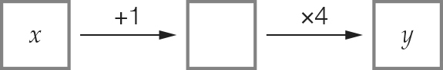

(b) y = 4 (x + 1)

(c)

|  |  |  |  |  |
| --- | --- | --- | --- | --- |
| x | 2 | 3 | 5 | 6 |
| y | 12 | 16 | 24 | 28 |

Question 24 2 marks [5.3]

|  |  |  |  |  |
| --- | --- | --- | --- | --- |
| x | 1 | 7 | 18 | 14 |
| y | 9 | 27 | 60 | 48 |

Question 25 3 marks [5.3]

(a) y =  (b) y = 40 – m (c) q = 4p2

Question 26 2 marks [5.3]

y = 

Question 27 4 marks [5.3]

(a)

|  |  |  |  |  |
| --- | --- | --- | --- | --- |
| Number of cards, n | 10 | 12 | 20 | 100 |
| Cost to produce the cards, C | $120 | $130 | $170 | $570 |

(b) C = 70 + 5n

Question 28 2 marks [5.4]

(a) 2(3 + 4) = 2 × 7 = 14 True

(b) 7 × 5 – 20 = 35 – 20 = 15 False

Question 29 2 marks [5.4]

Multiply by 4 then divide by 5.

|  |  |  |  |  |
| --- | --- | --- | --- | --- |
| m | 10 | 15 | 20 | 30 |
| n | 8 | 12 | 16 | 24 |

Question 30 2 marks [5.4]

d = 5 × 22 = 20 m

Question 31 6 marks [5.6]

(a)

|  |  |  |  |  |  |
| --- | --- | --- | --- | --- | --- |
| Number of shapes, S | 1 | 2 | 3 | 4 | 5 |
| Number of matches, M | 6 | 11 | 16 | 21 | 26 |

(b) M = 5S + 1

(c) M = 5 × 30 + 1 = 151

Question 32 6 marks [5.6]

(a) 27p (b) 3mn (c) 10a2 + 4

(d) -3j + 4 (e) 8p + q (f) 9m + 5n + 4

Question 33 2 marks [5.6]

(g– h) + (g – h) + (g– h) + (g – h) + (g– h)  
= 5(g – h)  
= 5g – 5h

Question 34 4 marks [5.7]

A (2, 4) B (-3, 1) C (0, -2) D (3, -4)

Question 35 8 marks [5.8]

(a)

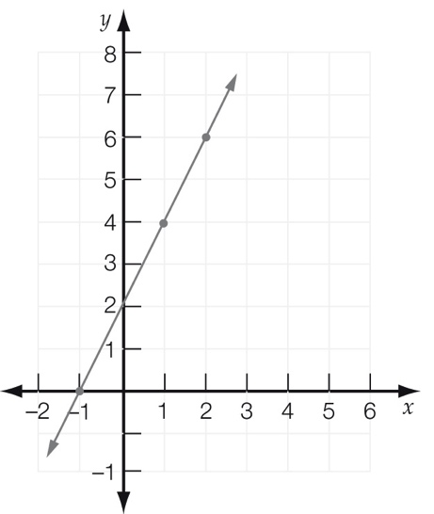

(b)

|  |  |  |  |  |
| --- | --- | --- | --- | --- |
| x | -1 | 0 | 1 | 2 |
| y | 0 | 2 | 4 | 6 |

(c) y = 2x + 2

(d) Various answers possible: (3, 8)

Question 36 3 marks [5.9]

The weights from lightest to heaviest are wombat, emu and then cow.

The heights from shortest to tallest are wombat, cow and then emu.

emu C cow A wombat B

Question 37 6 marks [5.9]

(a) From 12 noon until 2 pm is 2 hours.

(b) From 11 am until noon is 1 hour.  
From 2 pm until 2:30 pm is 30 minutes.  
From 3:30 pm until 4 pm is 30 minutes.  
So, total time travelling is 2 hours.

(c) 35 km + 35 km = 70 km

(d) 30 km in hour is a speed of 60 km/hour.

Short answer total: 79

Extended answer section

Question 38 4 marks [5.2]

(a) E = 10m + 5n

(b) 100 = 10m + 5n  
Some possible values for m and n are:  
1 and 18, 2 and 16, 3 and 14, 4 and 12, 5 and 10, 6 and 8, 7 and 6, 8 and 4, 9 and 2

Question 39 5 marks [5.3]

(a) 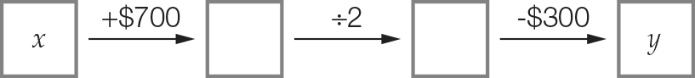

(b) y =  – 300

(c) y =  – 300  
= 2400 – 300 = 2100

Question 40 6 marks [5.4]

(a) n = 10b + 20

(b) C = 

(c) C =  = 2 cans  
n = 10 × 120 + 20 = 1220 nails

Question 41 5 marks [5.6]

(a) Fourth deposit  
x + 4 + 4 + 4 = x + 12

(b) x + (x + 4) + (x + 8) + (x + 12) = 4x + 24

(c) If x = 11, then total deposit:  
4 × 11 + 24 = $68

Question 42 5 marks [5.8]

(a)–(c)

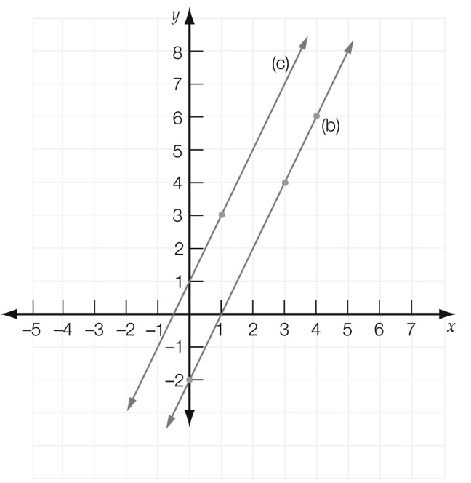

(d) y = 5

Extended answer total: 25

TOTAL test marks: 118